Docker installation on Windows.  
step 1: please go through below link  
[Docker Desktop: The #1 Containerization Tool for Developers | Docker](https://www.docker.com/products/docker-desktop/)  
  
possible error and solutions  
  
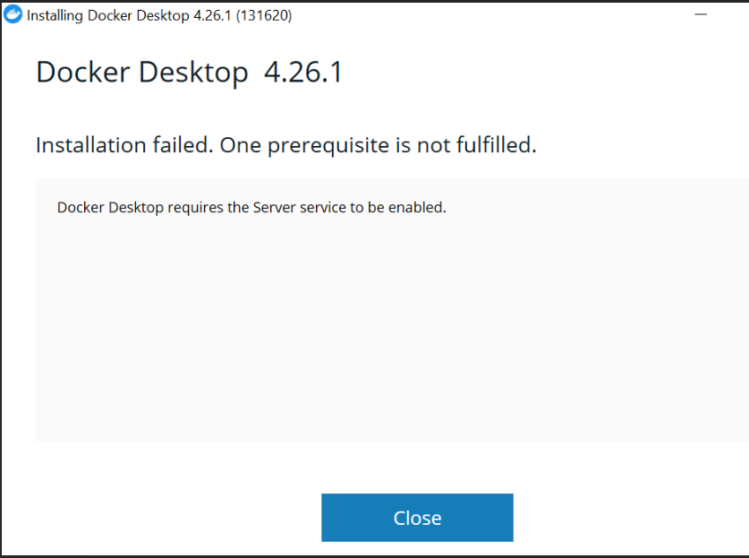  
  
Solutions  
started the service from task manager  
setp 1: Open service with Administrator  
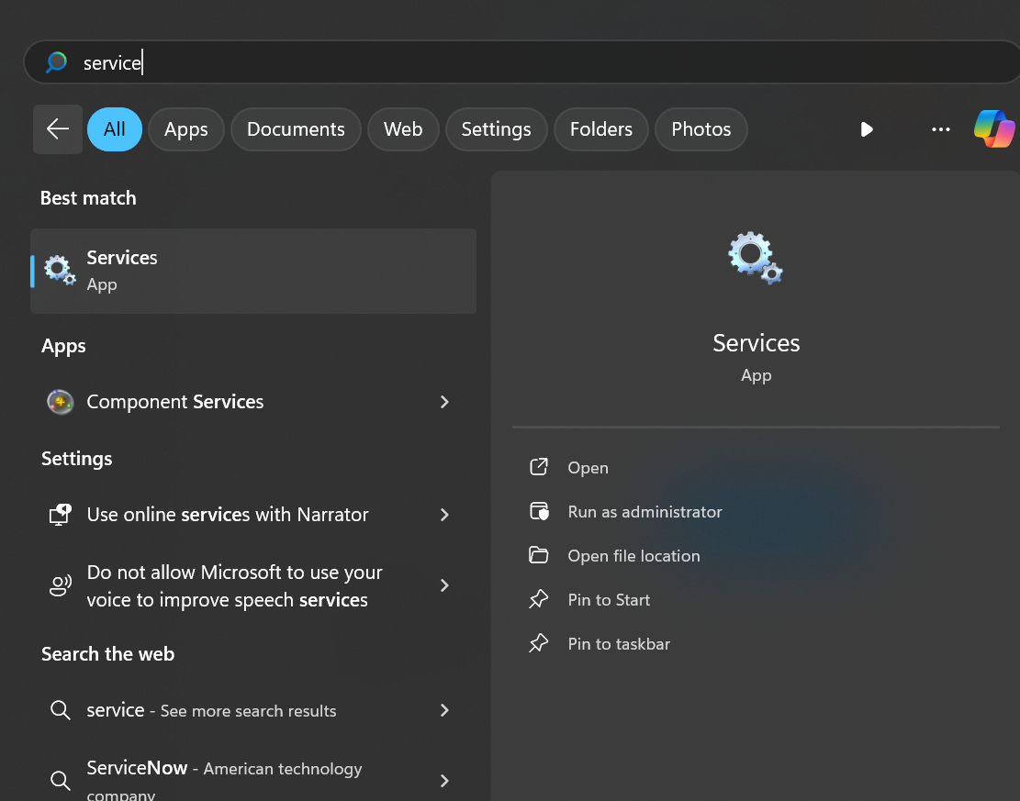

Step2: Server should be running   
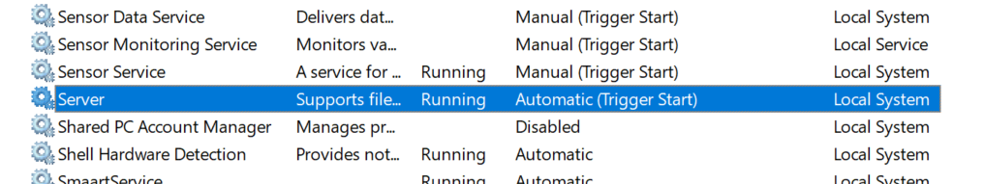  
Step3: If server is not running  
  
click on server , when it opens , in place of disabled , change it to Automatically  
Step4:  
